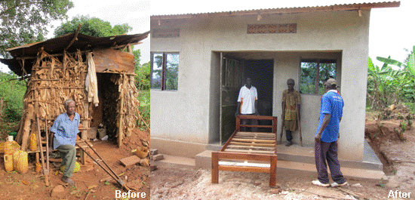

Dear OOKs,

OOKs GNR Fundraising Update 4 – A Good Day at the Office
Although my job at Advantage Africa is enormously challenging, it can also be incredibly fulfilling, and a good day at the office always involves feedback from our partners in East Africa about the impact of the work we are doing together. Like today, when we received photographs from our project in Kirondo, Uganda.
This particular project has enabled more than 100 vulnerable single-parent families to access safe water, be protected from malaria, cope with the impact of HIV and overcome chronic poverty by rearing goats, pigs or poultry. The most vulnerable in the community, including orphans, disabled and elderly people, have received mattresses/blankets, wheelchairs/mobility aids and taken part in training to understand and deal with alcohol and drug abuse. The project has even addressed housing, in one case helping an elderly and destitute man called Charles with a new house to replace the tiny shelter made of maize stalks in which he previously lived. I thought you might like to see the picture I took of Charles outside his shelter some time ago alongside the shot of his new house and bed that we received this morning. Perhaps you could regard these pictures as a symbol of the difference that you and your sponsors can make to disadvantaged people like Charles through your Great North Run fundraising!
The Kirondo project was born directly out of the needs of the community and is managed by them - and that’s what will help ensure the sustainability of all the activities undertaken. For example, the whole community rallied round to help collect materials and dig the foundation for Charles’s house and the project leader is keeping an eye on his continued good welfare. The sense of optimism and hope that has arisen from undertaking the project activities together has been extraordinary, and helps makes Kirondo a good example of how Advantage Africa really is a small charity making a big difference.
Thank you for fundraising to help people like Charles in Kirondo have a better life.
With best wishes,
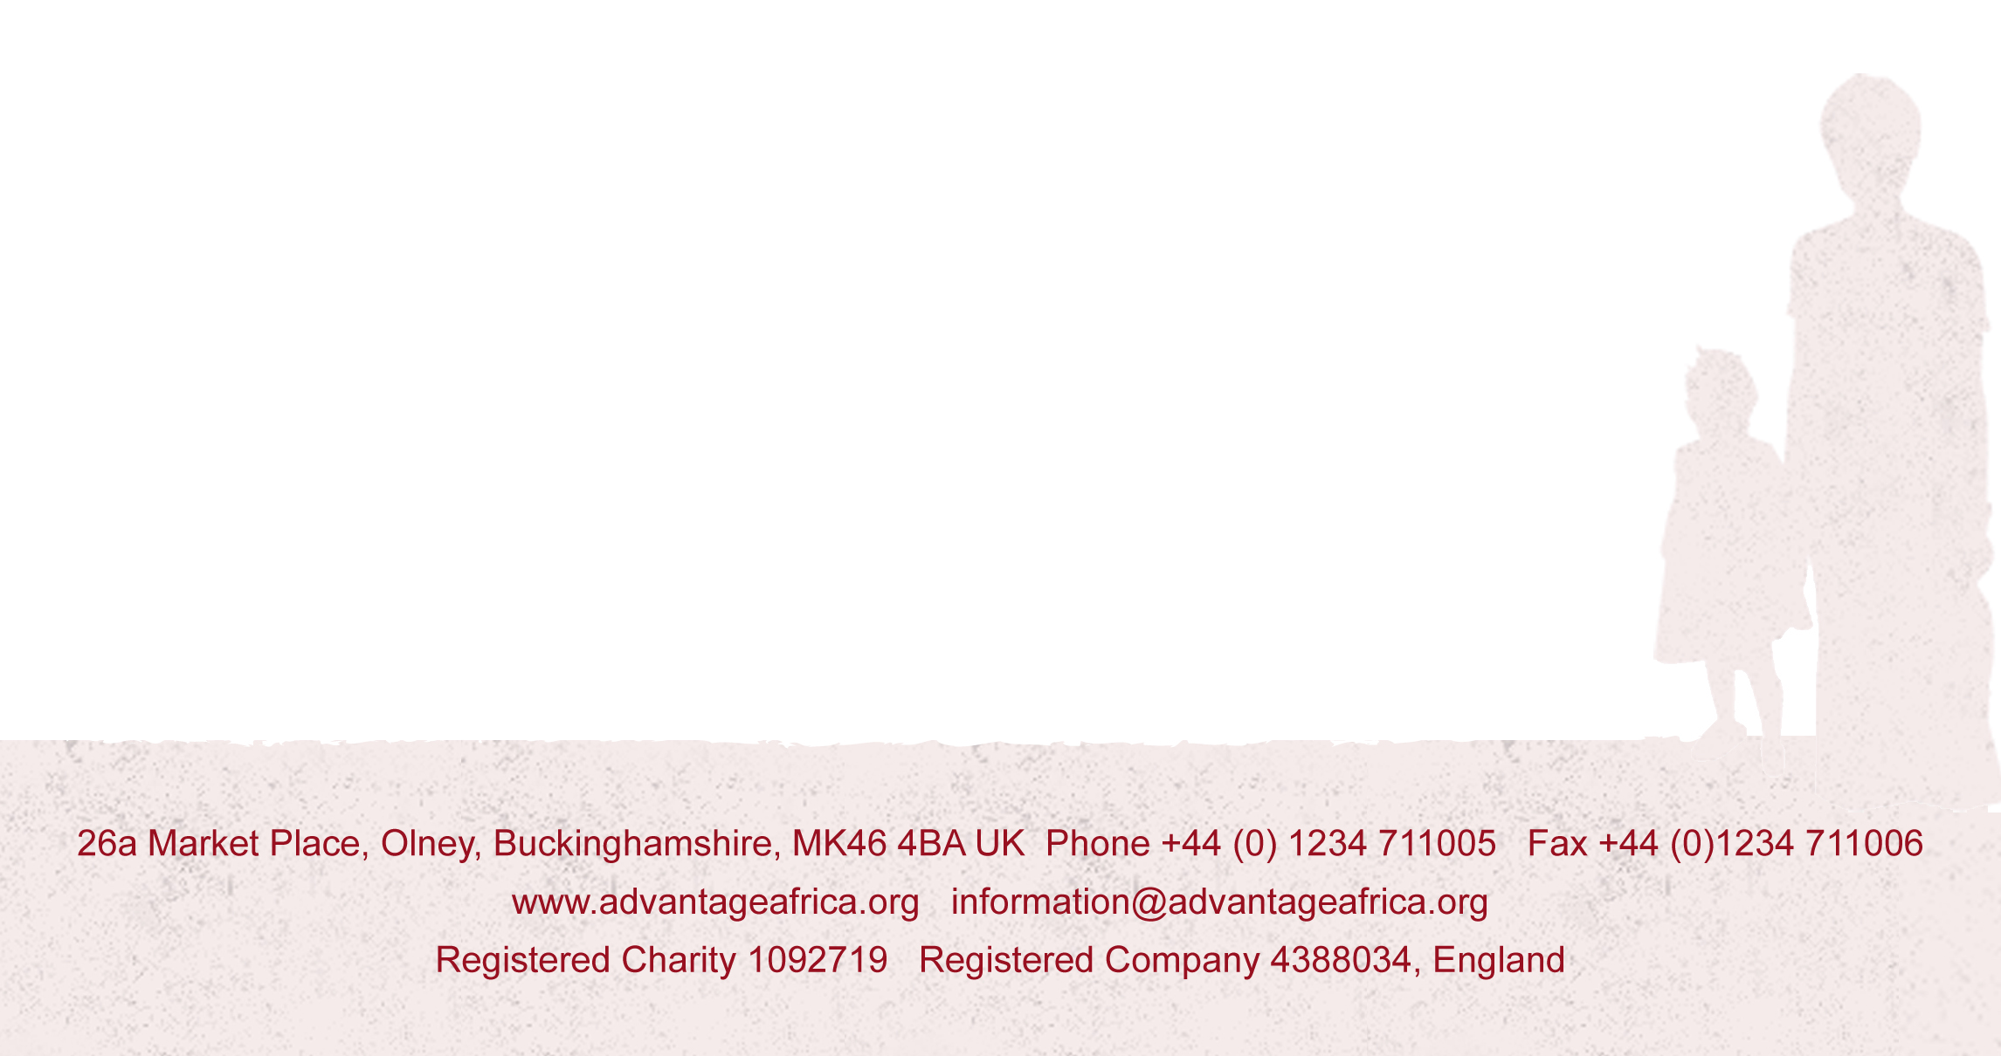
Andrew

